

AM804001: Project Management
Assessment 1: Case Study

Study block 2
Date issued
Due date |  |  |  |  | Time
Delivery: |  | Submit to Turnitin via Moodle before deadline
Weighting |  | 30%
Marks out of |  | 20
Instructions |  | Complete this cover sheet and attach to you your assignment.  - This assignment must be your own work.  - Collusion, copying or plagiarism may result in disciplinary action.  - We advise that you keep a copy of this assignment.  - Word limit is 2000  Refer to following website for reference related resources: http://www.cite.auckland.ac.nz/index.php?p=quickcite
We confirm that:

This is an original assessment and is entirely my own work.

Where ideas, tables, diagrams etc. of other writers have been used, we have acknowledged the source in every case.

This assignment has not been, nor will be, submitted as assessed work for any other academic course.
Student’s Name |  |  | ID No |  |  | Signature
Date |  |  |  | Cohort Number |  |  |  | 1

CONTENTS
1. Introduction 5
Project Management Methodologies (VR Learning Platform for Healthcare Training) 5
2.1 WATERFALL 5
2.2 SCRUM 7
2.3 EXTREME PROGRAMMING (XP) 9
Critical evaluation of chosen methodology … 10
4. MAORI INCLUSION IN THE PROJECT 11
References 13

Introduction

This report focuses on the case study of developing a Virtual Reality (VR) Learning Platform for Healthcare Training at Otago Polytechnic. The goal of this initiative is to establish an immersive VR space where healthcare and nursing students can engage in simulated medical procedures, practicing tasks such as patient diagnosis and emergency response within a virtual hospital environment. The platform will feature multi-user functionality, allowing students to collaborate in real time, and will also need to seamlessly integrate with the Polytechnic's current Learning Management System (LMS). Additionally, the project must incorporate culturally responsive healthcare practices rooted in Iwi/Māori health frameworks and traditions.

The project will also require user training for both students and lecturers, ensuring they are confident in using the VR technology. Key deliverables include high-quality VR hardware and software, a user guide, a training program, a culturally inclusive healthcare curriculum embedded in the VR simulations, and a risk management plan addressing potential technology malfunctions and user resistance.

In the current COVID-19 situation, the demand for virtual learning tools has increased significantly, making this project timely and relevant. However, the project may face challenges such as technological limitations, user resistance, and the need for culturally sensitive content.

To carry out this project, three project management methodologies have been suggested: Waterfall, Scrum, and Extreme Programming. Out of these, Scrum is considered the most appropriate methodology for this project due to its flexibility, iterative approach, and ability to handle complex, evolving requirements.

Project Management Methodologies (VR Learning Platform for Healthcare Training)

2.1 WATERFALL
The Waterfall Model is a project management methodology that has been around since the 1950s. It is a linear and sequential approach to project management, where each phase of a project must be completed before moving on to the next (Clifford, 2023).

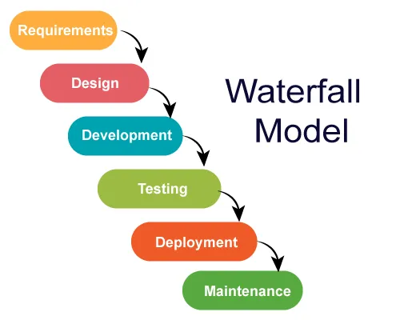

REQUIREMENTS PHASE
This is the initial planning process in which the team gathers as much information as possible to ensure a successful project. Because tasks in the waterfall method are dependent on previous steps, it requires a lot of forethought. This planning process is a crucial part of the waterfall model, and because of that, most of the project timeline is often spent planning (Laoyan, 2024).
DESIGN PHASE
The design phase is when the project team specifies what hardware the team will be using, and other detailed information such as programming languages, unit testing, and user interfaces. This phase of the waterfall methodology is key to ensuring that the software will meet the required functionality and performance metrics phase solidifies and documents the options chosen in the first phase (Laoyan, 2024). This is called a “design document”. It lays out everything that will be needed to bring the project to life: technical specifications, procedures and processes, testing criteria, and success metrics (Icasas, 2025).
DEVELOPMENT PHASE
This is the stage where everything is put into action. The team starts the full development process to build the software in accordance with both the requirements phase and the system design phase, using the requirements document from step one and the system design process from step two as guides (Laoyan, 2024).
TESTING PHASE
This phase deals with the real testing and checking of the software solutions that have been developed to meet the original requirements. Also, it is the phase where the bugs and system glitches are found, fixed up, and refined (Alshamrani & Bahattab, 2015).
DEPLOYMENT PHASE
Once testing is complete and the software is fully functional, it’s deployed to the production environment. This is when the software is made available for end users (Jain, 2024).
MAINTENANCE PHASE
After the software is already released, it may need some modifications, improvements, errors correction, and refinement accordingly. Thus, this phase is the process of taking care of such concerns (Jain, 2024).

2.2 SCRUM

Scrum is an agile approach to software development that focuses on working in small, manageable chunks. It's a way of developing products that’s flexible and collaborative, allowing teams to adapt quickly as they go. The concept was first introduced in 1986 by Hirotaka Takeuchi and Ikujiro Nonaka in their work The New Product Development Game. They described it as a way for development teams to work together as a cohesive unit, all aiming toward the same goal (Sachdeva, 2016).
Scrum challenges the traditional, step-by-step methods of product development by emphasizing self-organizing teams. The idea is that when team members collaborate closely, both online and face-to-face, it leads to better outcomes. Instead of working in isolation, everyone on the team contributes and communicates, helping the project move forward more smoothly and flexibly. (Sachdeva, 2016). Scrum was developed in 1993 by Jeffrey Sutherland at the Easel Corporation, to deliver quality software products in small time intervals known as sprints (Sassa et al., 2023).
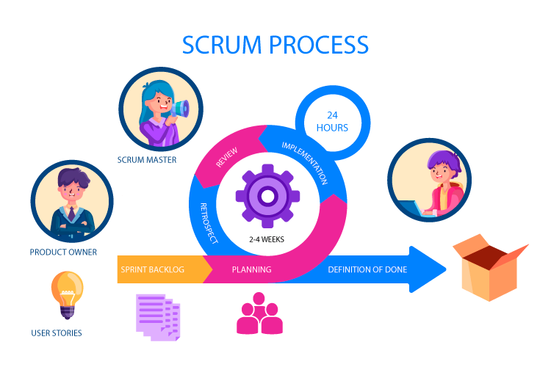
PLANNING PHASE
At the beginning of each Sprint, the Scrum Team conducts a Sprint Planning meeting. This event focuses on setting the Sprint Goal and selecting items from the Product Backlog to work on during the Sprint (Bhaskar, 2024).
IMPLEMENTATION PHASE
The implementation phase is about the execution of tasks and activities to accomplish product goals and complete project deliverables. Daily stand-up meetings are regular (but quick) touch bases that the team does to check on task status, align on sprint progress, and check for possible issues. During these meetings, each team member gets the chance to share the following: What tasks they did yesterday, What tasks they plan to work on next today, What issues they faced (if any) (Donato, 2023).
REVIEW PHASE
After the sprint, the Scrum Team holds a Sprint Review to showcase the work completed during the Sprint. Stakeholders provide feedback, and the Product Backlog is adjusted as needed (Bhaskar, 2024). The Development Team is present to show their work and receive feedback. They're hopefully also there to connect to their stakeholders. The Product Owner is also there for the feedback, but also to verify the longer term road-map and the state of the product backlog. The Stakeholders often come to see the things they requested. We also ask them to share insights they have gathered during the sprint and to collaborate on the Product Backlog (Houwing, 2019).
RETROSPECTIVE PHASE
The retrospective is the principal means through which a team focuses on continuous process improvement. As such, retrospectives provide Scrum teams a method which will allow them to identify and resolve issues that impact team performance (Marshburn, 2018). This allows scrum teams to identify which part they did well, which part they did not do well, and what actions they can implement on the next sprint to improve their process.

EXTREME PROGRAMMING (XP)

Extreme Programming (XP) is an another agile methodology that focuses on rapid development, continuous feedback, and high-quality software delivery. XP’s origin dates back to the 90s when Kent Beck – who would later become one of the authors of the Agile Manifesto – created it when hired to lead Chrysler’s Comprehensive Compensation System team (Venema, 2024). XP values communication, simplicity, feedback, courage, and respect, using them as guides for time management and technique. XP employs practices that encourage creativity while acknowledging human fallibility, to produce quality software sustainably. XP teams aim for transparency and accountability, mirroring typical business operations, while also celebrating the human element involved in software creation. This approach allows teams to develop software at a lower cost, with fewer defects, higher productivity, and a greater return on investment. XP assumes team members want to collaborate, improve their skills and relationships, and are willing to adapt to achieve shared goals (Beck, 2000).

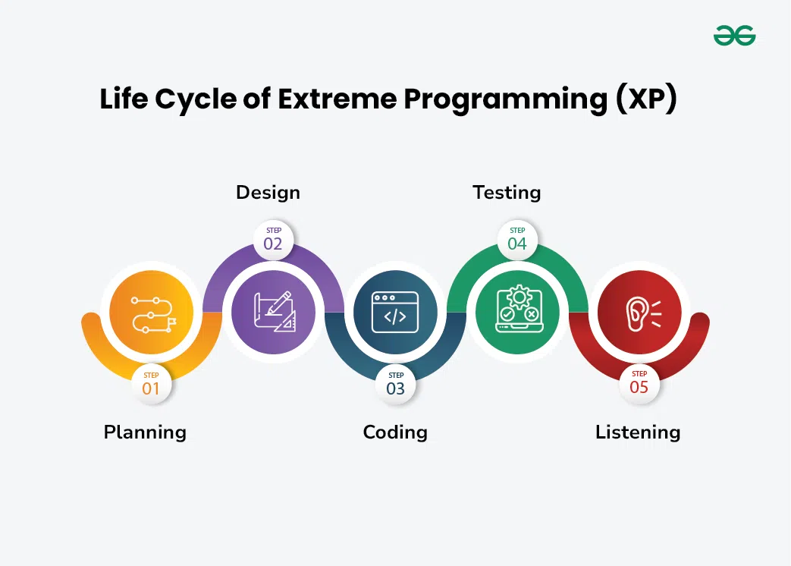

PLANNING PHASE
Planning defines the first phase of the XP lifecycle. In this stage, customers meet the team of developers and outline their requirements through user stories that reveal the desired result. The team then uses these client requirements to create multiple iterations necessary to achieve the desired functionality on a part-by-part basis. In situations where user stories are challenging to estimate and develop iterations, ‘spikes’ are introduced, which signify the necessity for further research (Kanade, 2022).

DESIGN PHASE
Designing is a subpart of the planning phase. It covers one of the principle XP values:’ simplicity’. This implies that a good quality design gives definitive logic and structure to system implementation and reduces unnecessary complexities and redundancies (Kanade, 2022).
CODING PHASE
Coding is the most critical phase of all the lifecycle stages. Here, code is written by following coding standards that fall under specific XP practices such as pair programming, metaphor, regular integration, refactoring, code review with collective code ownership, and so on (Kanade, 2022).
TESTING PHASE
The testing phase comes after the coding stage. The development process routinely involves two tests: unit tests and acceptance tests. Unit tests refer to automated testing practices that confirm whether the developed features work as intended. Acceptance tests relate to customer testing, which determines whether the overall system is developed by keeping initial user requirements in mind. The testing phase validates the performance of codes and gives insights into bugs that may arise in specific scenarios (Kanade, 2022).
LISTENING PHASE
The listening phase applies to every development stage. It implies maintaining constant communication and feedback with the clients to ensure that their expectations and requirements are always met. Besides listening to client requirements, developers can also input the technical aspects of refining the overall system by altering certain software features (Kanade, 2022).

Critical evaluation of chosen methodology …

After evaluating the three methodologies, Scrum is the most suitable project management methodology for the implementation of the Virtual Reality (VR) Learning Platform for Healthcare Training at Otago Polytechnic. This is primarily due to Scrum’s iterative, collaborative, and flexible approach, which aligns well with the complex and innovative nature of the project. Below are the key reasons why Scrum is the best fit for this initiative.

Firstly, Scrum’s iterative development process allows for continuous improvement and adaptation. The VR platform involves cutting-edge technology and requires frequent testing and refinement to ensure it meets the needs of students and lecturers. By breaking the project into smaller, manageable sprints, the development team can deliver incremental updates, gather feedback, and make necessary adjustments. This is particularly important for ensuring the platform’s immersive 3D environments, multi-user capabilities, and integrated feedback system function seamlessly (Schwaber & Sutherland, 2020).
Second, Scrum emphasizes collaboration and communication, which is critical for a project involving multiple stakeholders, including students, lecturers, software developers, and healthcare professionals. The daily stand-ups, sprint reviews, and retrospectives foster transparency and ensure that everyone is aligned with the project’s goals. This collaborative approach is essential for integrating culturally responsive healthcare practices rooted in Iwi/Māori health frameworks, as it requires ongoing dialogue and input from diverse stakeholders (Rubin, 2012).
Thirdly, Scrum’s flexibility makes it ideal for addressing the uncertainties and challenges inherent in developing a VR platform. For instance, the risk management plan for technology malfunctions and user resistance can be continuously updated based on real-time feedback and testing. This adaptability ensures that potential issues are identified and resolved early, minimizing disruptions to the project (Sutherland & Sutherland, 2014).
Lastly, Scrum’s focus on delivering value incrementally ensures that the platform’s key features, such as role-playing for multiple participants and integration with the existing LMS, are prioritized and developed efficiently. This approach also allows for early user training, ensuring that students and lecturers become confident with the VR technology as it evolves (Mike, 2010).
In conclusion, Scrum’s iterative, collaborative, and flexible framework makes it the most suitable methodology for the VR Learning Platform project. It enables continuous improvement, fosters stakeholder collaboration, and ensures the timely delivery of high-quality, culturally inclusive healthcare training solutions.

4. MAORI INCLUSION IN THE PROJECT
Incorporating Māori values into the VR Learning Platform for Healthcare Training at Otago Polytechnic is essential to ensure the project aligns with culturally responsive healthcare practices and respects the principles of Te Tiriti o Waitangi (The Treaty of Waitangi). Three key Māori values that can be integrated into the project are Whanaungatanga (relationships and connections), Manaakitanga (care and hospitality), and Kaitiakitanga (guardianship and sustainability). These values will guide the development, implementation, and use of the VR platform to ensure it is inclusive, respectful, and effective for all users.

1. Whanaungatanga (Relationships and Connections)
Whanaungatanga refers to the importance of building and maintaining good relationships, which is something that is absolutely crucial in healthcare settings. On the VR platform, this can be translated through the establishment of multi-user functionalities that enable teamwork and collaboration among students. The platform, for example, can simulate an environment where students work together to diagnose and treat patients, which is the collaborative practice of healthcare. Secondly, the platform can engage virtually with Māori patients and whānau (families), so they learn how to build trust and rapport in culturally sensitive ways. Lastly, the platform can feature translations in Te Reo Maori in talks and signage. It highlights the importance of relationship-centered care towards improving health outcomes for Māori, in such a way that this core value is guiding the design of the platform (Curtis et al., 2019).

2. Manaakitanga (Care and Hospitality)
Manaakitanga is hospitality, care, and respect, and these can be embedded on the VR Learning Platform through the construction of a gracious and hospitable environment for Māori students and lecturers. This involves creating an easy-to-use interface, adding appropriate culturally grounded content, and providing personalized feedback to improve learning for students. Scrum's emphasis in collaboration and stakeholder feedback ensures the platform is always responsive to the needs of its users, and a feeling of care and respect is preserved during the development process. Regular consultation with Māori learners and specialists ensures the project upholds Manaakitanga, ensuring the platform offers a respectful and welcoming space for all (Smith, 2021).

3. Kaitiakitanga (Guardianship and Sustainability)
Kaitiakitanga is a Māori value centered around guardianship, where individuals and communities take responsibility for protecting and nurturing in environment and natural resources. In the VR Learning Platform project, this value can be reflected by making the platform environmentally sustainable, minimizing its impact, and encouraging responsible resource usage. It also incorporates Māori health models within the VR simulation to honor and preserve Māori cultural values. The iterative structure of Scrum enables the team to continuously experiment and improve both the technological and environmental aspects of the platform, ensuring it aligns with cultural and ecological care. (Berkes, 2018).

References
Alshamrani, A., & Bahattab, A. (2015). A Comparison Between Three SDLC Models Waterfall Model, Spiral Model, and Incremental/Iterative Model. International Journal of Computer Science Issues (IJCSI), 12(1), 106–111.
Beck, K. (2000). Extreme programming explained: Embrace change. addison-wesley professional.
Berkes, F. (2018). Sacred ecology (4th ed.). Routledge.
Bhaskar, S. (2024). What is Scrum Methodology? An Introduction for Agile Teams. Nimblework. https://www.nimblework.com/agile/scrum-methodology/
Clifford, D. (2023). The Waterfall Model: A brief overview of its history and development in project management. Medium. https://medium.com/smart-project-kit/the-waterfall-model-a-brief-overview-of-its-history-and-development-in-project-management-f991ee981fea
Curtis, E., Jones, R., Tipene-Leach, D., Walker, C., Loring, B., Paine, S.-J., & Reid, P. (2019). Why cultural safety rather than cultural competency is required to achieve health equity: A literature review and recommended definition. International Journal for Equity in Health, 18(1), 174. https://doi.org/10.1186/s12939-019-1082-3
Donato, H. (2023). What Are The Phases Of Scrum? Workamajig. https://www.workamajig.com/blog/scrum-methodology-guide/scrum-phases
Houwing, J. (2019). Focus on what was “Done” during Sprint Review. Jessehouwing. https://jessehouwing.net/scrum-sprint-review-focus-on-done-and-product-backlog/
Icasas, P. (2025). What are the Six Phases of Waterfall Project Management? Birdviewpsa. https://birdviewpsa.com/blog/six-phases-waterfall-project-management/
Jain, S. (2024). What is Waterfall Lifecycle. Browserstack. https://www.browserstack.com/guide/waterfall-model
Kanade, V. (2022). What Is Extreme Programming? Meaning, Working, and Principles. Spiceworks. https://www.spiceworks.com/tech/devops/articles/what-is-extreme-programming/
Laoyan, S. (2024). Guide to waterfall methodology: Free template and examples. Asana. https://asana.com/resources/waterfall-project-management-methodology
Marshburn, D. (2018). SCRUM RETROSPECTIVES: MEASURING AND IMPROVING EFFECTIVENESS. Proceedings of the SAIS 2018. https://aisel.aisnet.org/cgi/viewcontent.cgi?article=1008&context=sais2018
Mike, C. (2010). Succeeding with agile: Software development using Scrum. Pearson Education.
Rubin, K. (2012). Essential Scrum: A practical guide to the most popular Agile process. Addison-Wesley.
Sachdeva, S. (2016). Scrum Methodology. International Journal of Engineering and Computer Science, 5(6). http://www.ijecs.in/index.php/ijecs/article/view/1989
Sassa, A., Almeida, I., Pereira, T., & Oliveira, M. (2023). Scrum: A Systematic Literature Review. International Journal of Advanced Computer Science and Applications, 14. https://doi.org/10.14569/IJACSA.2023.0140420
Schwaber, K., & Sutherland, J. (2020). The Scrum Guide. Scrumguides.Org. https://scrumguides.org/docs/scrumguide/v2020/2020-Scrum-Guide-US.pdf
Smith, L. T. (2021). Decolonizing methodologies: Research and indigenous peoples. Bloomsbury Publishing.
Sutherland, J., & Sutherland, J. J. (2014). Scrum: The art of doing twice the work in half the time. Addison-Wesley.
Venema, M. (2024). What Is Extreme Programming (XP)? Nimblework. https://www.nimblework.com/agile/extreme-programming-xp/

